**Clinic Management System**

In Partial Fulfillment of the Requirements

for the Degree BS in Information Technology (BSIT) Program

PHINMA Saint Jude College

Submitted To:

**Mr. Dan Lester B. Belarmino**

Submitted By:

**Tulipas, Aaron**

**Galino, Grexter**

**Calagos, Patrick**

**Gloda, John Bryan E.**

**Nepomuceno, Cherry Ann**

**Balote, Mark Ivan**

November 2022

CHAPTER 1

**THE PROBLEM AND ITS BACKGROUND**

In today’s modern age where computer has become a way of life, it is evident that a majority of the country’s institutions still do not adapt the high technology. Particularly in most medical clinic facilities, daily clinic transactions are still done on paper. We all know that modern clinics are now operating at great pace striving to serve as many patients as possible with the best of their abilities. But as the years rolled by, the number of patients has grown and various medical cases arise that the manual method of managing patients’ records, prescriptions, and appointment schedule, is no longer practical.

In this study, we hope to develop a web-based application that will minimize all paper works and manual records keeping, therefore allowing doctors and staff ease in keeping track of patients, reducing patients’ waiting time and increasing the number of patients served – a system that is fully automated, user-friendly, time effective and efficient.

The facility still uses the outdated method of keeping such records for admissions. In other ways, they continue to rely on outdated recording techniques; for example, the workspace is still taken up by physical record books and folders where files are still preserved. This has presented a problem for the clinic's recording procedure. Because the Clinic's current recording procedure still relies on antiquated practices such filling out paper forms for recording, which can result in significant paper waste, the system's developers chose to automate those procedures. Doctors, nurses, and midwives may quickly encode the patient's clinical information and prescribed medications using the Maternity Clinic Management System. They can also keep track of their patients' clinic appointments or routine exams.

**CONCEPTUAL FRAMEWORK (IPO)**

Input

New patients:

* Enter information on Clinic Management System
* Choose schedule of appointment

Registered patients:

* Login
* Choose schedule of appointment

Registered patients:

* Login
* Choose schedule of appointment

Doctors/Admin

* Add medical record
* Patient Data
* Services Data

Output

* Schedule appointment
* E-prescription
* Digital Medical Certificate
* Automated track of patient records
* Secure patient database

Process

* Monitoring of Client’s records
* Doctor accomplish checklist of medical and prescriptions
* Process Appointment

**Statement of the Problem**

* What are the common problems encountered with the existing manual system of managing a clinic?
* What are the possible solutions to the problems encountered with the current system?
* What is the difference between the manual system and the proposed system?

**Hypothesis of the Study**

The profiles of the respondents taken are their age, gender, occupation and civil status. The manual system is very time consuming, inconvenient and strenuous when it comes to recording, updating, storing, organizing, and retrieving patient’s records in the cabinet. The proposed online system is the best solution to do away with the old method of data keeping such as folders and file cabinets, which do not allow easy retrieval. Not only will records be more accurate, the clinic can also accommodate more patients than ever before.

**Scope and Delimitation**

In this proposed system, records and files are computerized and stored online for accessibility and portability. However, the proponents limit the online feature of the system to doctors and staff only. Web-access of the patients is not included. The system has a secure log-in for doctors and staff. Managing appointments is also integrated and billing statements and official receipts are automated as well as medical prescriptions and medical certificates.

**Significance of the Study**

**SAINT JUDE COLLEGE**

The purpose of the patient record and information system is to assist the school clinic in better documenting and maintaining files, in organizing patient records or medical histories, and in protecting confidential information from unauthorized parties.

**DOCTOR**

With the suggested system, managing the clinic will be simpler for the doctors, and it will be convenient to get patient records.

**PATIENT**

To manage and update their health status, the system aids students and patients. And it's an effective strategy for protecting the health of the students.

**CLINIC**

The Patients Record and Information System was developed to allow faster patient/student data recording than the present manual system.

**FUTURE RESEARCHER**

This will help other researchers who want to conduct similar investigations since they can use the findings of this study as a template to adapt their own research and gain background knowledge.

**DEFINITION OF TERMS**

An integrated information system called a clinic management system is used to manage every area of a medical clinic's operations, including compliance, administration, finance, and administration. It encompasses revenue cycle management, business intelligence, and electronic health records.

**PRESCRIPTION**

Prescription Details ( Lab Form No, Presciption Form No, Drug Name,  
Quantity, and Doctor’s No)  
  
Doctor ( Doctor’s No, Doctor’s Name)  
Patient (Reg No, Patient’s Name,)

CHAPTER 2

**Review Of Related Literature**

This chapter contains the foreign and local studies related to the system that are cited from articles and journals pragmatic are based on research and design of the developer to meet the customer’s need.

**NOTE: LOCAL AND FOREIGN (AT LEAST 2)**Local Literature

Top Philippine hospitals are currently using a web-based electronic medical records system for doctors and a laboratory information system designed to support a future integrated healthcare system in which each patient has one complete record. It, like the Maternity Clinic Management System, keeps patient records and makes important patient data available. It also prints the forms that must be completed. (“Medcurial,” 2001)

MyKlinika, like Maternity Clinic Management System, is a customized clinic management system used to organize, manage, and monitor a clinic's patients' records as well as medicines and medical supplies inventory. This is a cloud-based application that allows you to manage and monitor multiple clinics by defining groups per site or clinic. This is intended for mobile doctors who manage a number of clinics in various locations. (“MyKlinika”, 2017)

e-Clinic is a web-based and mobile-based system that provides SMS notifications and has booking, marketing, reporting, and clinical features designed specifically for healthcare practitioners. Maternity Clinic Management System also includes an SMS notification, allowing push notifications to be sent via SMS. (From "e-Clinic," 2004.)

The only scalable clinic and pharmacy management software from prescription processing to over-the-counter POS, Medeil Plus is a web-based system that is efficient for managing medical practices and pharmacies. It tends to be the most reasonably priced system available. Users may also schedule appointments at the clinic using it. Similar to the Maternity Clinic Management System, it also provides appointment setting so that the medical staff of the IMMS Maternity Clinic may keep track of each patient's appointments in accordance with the date that they were scheduled with the clinic ("Medeil Plus," 2014).

Foreign Literature

Clinics Management System (CMS) based on Patient Ontology "The growing diversity and differentiation in healthcare today is a significant issue. According to Prasad M. Jayaweera (University of Ruhanna, Sri Lanka), process-oriented business ontologies are developed in a customer-centered manner in order to develop business systems applications to provide more and more value-added services to target consumers. New medical specialties are constantly being created, and there are numerous roles involved in patient care. Despite some constraints and restrictions that can be seen in Sri Lankan healthcare, this tendency is also present there.

Foreign Studies

Without improved management systems, clinics cannot improve, claims Toussaint (2015). According to Toussaint, management has a big role in the current cost and quality crises in healthcare. According to Agnes (2011), there must be a planned method to work. This is why relevant clinic needs and competent medicalmanagement must be there to give applicable healthcare facilities. Therefore, the clinic's operations must be well thought out and coordinated. Accordingly, researchers discovered that processing clinic information must be done accurately and according to standards. In conclusion, while the errors are minimized, they are not entirely gone.

**Related Systems**

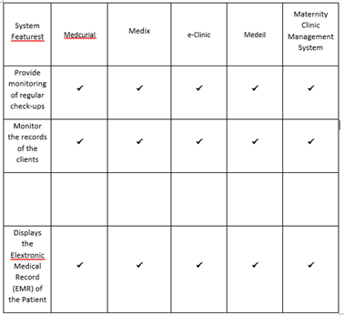

**Synthesis**

The methods were the same across all systems, domestic and international, but the proponents pointed out that the built-in inventory system is one aspect that hasn't yet been implemented.

Although there were several clinics, such as eye, and others, the controlling processes were the same and they were linked from our system. Some of the features coincide with the proposed system, Maternity Clinic Management System. To arrive to this investigative analysis, the researchers conduct extensive observation and additional study.

The proponents further understood some functions that could be added, advanced, accurate, and useful where it could help to make the daily process hassle-free and gradually cast out the old methods of record keeping and a new embrace to technological advancement through close observation of the related systems.

Its ability to help the proponents of the study better analyze what are the fundamental requirements and improvements to a particular organization and put creative ideas into action to help overcome existing issues that a particular business or organization has is what it can contribute to the study. Additionally, it would serve as a preview for the supporters of the job type they will hold in the future in terms of the industry from which they will retire.

CHAPTER 3

**RESEARCH METHODOLOGY**

* Interviews
* Observations

**Population and sampling scheme**

Doctor and Patient – 3

**Description of Respondents**

* Students
* Doctors
* Patients

Research Instrument/s

This study used the descriptive-survey method, which is suitable whenever the subject vary themselves and interested to know the wholy to which different conditions and situations are obtained among this subjects. Survey research involved the use of questionnaires to gather data about one or more groups of people perhaps about their thoughts, attitudes, or previous experience, by asking questions.

**Data Gathering Procedure**

The respondents are chosen at random by the researchers, who then show them the method. The respondents are observed by the researchers based on their enthusiasm for technology, sincerity, and system knowledge. The researchers then assessed them using the given User-Acceptability questionnaire and gathered the information in order to further work on the statistical model.

**Methodology**

The approach that the proponents employed in designing the system is Rapid Application Development, and this chapter explains the research strategy, procedures, and system phases that they used (RAD).

**Requirement Gathering**

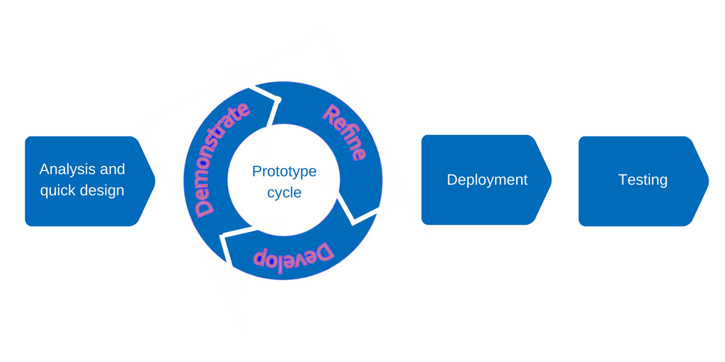

**Analysis and Quick Design**

The proponents acquired data from the clinic at tayuman for the analytical phase. The advocates discover a remedy for their manual system through information gathering, and this approach enables the introduction of IMM'S maternity management system. The proponents created a system during the design phase that will integrate manual patient recording into an automated maternity management system. The programmer starts creating the system when we decide on its design and functionality.

**Prototyping Cycle Phase**

* **Demonstration** - The advocates show off the system's features that match the criteria for improving the management process.

• **Development** - The mechanism that indicates and makes the automated IMMS maternity management system functional is programmed by the programmer. The response is willing to provide access to the fully operational imms maternity management system to conduct training on how to use or manipulate the system after it has been completed and made suitable for usage.

• **Refine** - Before testing, the system had already been polished by the cycle's proponents.

CHAPTER 4

**PRESENTATION, ANALYSIS, AND INTERPRETATION OF DATA**

The analysis of the data collected and gathered from the respondents of the patients, and doctors.

Presentation

* Design the interface of the clinic management system (interface design)
* Design the architecture of the clinic management system (architectural deisgn)
* Design the components of the clinic management system ( Component level design)
* Design data items of the clinic management system (data design)
* Test guidelines

Analysis

* Build prototype of the clinic management system
* Implement clinic management system data entry Windows
* Implement module / sections of the clinic management system

Testing

* Unit testing
* Integrated testing

**PATIENTS AND DOCTORS INTERVIEW – ANSWER ON THE INTERVIEW**  
Patients  
  
Question #1: Considering the current COVID – 19 situation, what are the benefits of scheduling online medical appointments for patients?  
  
  
 Respondent 1: I think, the beneficial part of having teleconsult is the, it is accessible and convenient to the patients because you are not required to go to the hospital just to have a consult, you can have a consult by via online or zoom

So, I think it also time efficient because as I said while ago you will not go to the hospital to have a check-up and also if you were going to have a follow-up check up, it will also be more time efficient and convenient.

Respondent 2: Because of the covid maraming nahihirapan na magpaconsult sa clinic or hospital kaya I think makakatulong and online medical appointment para mas mapadali yung proseso.  
   
  
  
 Question #2: Do you prefer to book online appointments rather than drop-in? If yes, Why?  
  
 Respondent 1: Sa akin po depende po sa situation, kung malapit naman sa hospital pumunta nalang kasi minsan may sinasabi tayong symptoms na physically para dun sa patients di naman niya nararamdaman pero it’s a factor  
pala pag nakita ng doctor actual, it is the same time, kung malayo yung hospital and given na yun pandemic nga is di natin sure kung sa consultation is may makatabi kang may covid tas mahawaan ka pa, so it’s high possibility na magkaron karin ng covid. So kung malapit lang naman yung clinic tapos hindi mo na kailangan gumamit ng maraming transportation or di ka makakahalubilo ng ibang tao like may private vehicle naman, ok lang naman pumunta sa mismong hospital para actually ma-check ng doctors or kung malayo mas magandang online nalang.

Respondent 2: If im gonna make an appointment I think its much better if drop in kasi masasabi mo yung mga concern mo ng mas detailed.  
  
  
Doctors  
  
Question #1: What are the problems faced by clinic using the traditional manual process?  
  
Respondent 1: Siguro, yung pinaka nakikita kong problem or yung mahirap ngayon sa mga clinic na gumagamit ng traditional manual process is yung una is matagal siya and meron kasing mga process na umaabot ng mga ilan days kapag mina-nual, katulad ng ginagawa naming ngayon na wala naman tayong sobrang machine.  
  
Respondent 2: For me. the problems that faced using the traditional manual process are no real time data available to monitor the performance of the hospital and Undue delays in receipt of data.  
  
  
Question #2: How is the clinic management system beneficial to doctor in handling their clinics?  
  
Respondent 1: Ayun nga, kapag kasi ngayon mas ok kung meron management na yung ginagamit sa modern ngayon na clinic na parang naka record na siya sa system lahat ng information about sa patients, and sa resulta kung ano yung mga test na ginawa as compare dati na sinusulat lang ng mano-mano yung ginagawa kapag ganun kasi, possible na mawala yung mga papers and what if magkasunog, so mahihirapan yung next na doctors na mag hahandle dun sa patients kaya mas ok na yung nasa system at anytime pwede siya ma access ng doctors.

Respondent 2: as a clinic doctors, our managements provides a suite of functionalities that makes it easy to manage a clinic. A medical practice management system is used to manage the patients, the appointments, the doctors schedules, prescriptions, manage inventory, etc.

**CHAPTER 5**

**SUMMARY OF FINDINGS, CONCLUSIONS, AND RECOMMENDATIONS**

**Summary Of Findings**

This system study was carried out in order to create a Clinic management system for Tayuman clinic in Sampaloc, Manila to meet the goals as mentioned in the objectives and to allow the clinic's monitoring of records function more quickly, efficiently, and effectively.

**Conclusion and Recommendation**

A lot of research and interview, as well as the documentation analysis need to be done in order to make sure that the information are accurate and the system is more efficient and also systematic. The research that had been done is concluding in the Literature Review. Analysis is done to make sure that the data can be used as a guideline for developing this system. There are existing systems which involve in this chapter. The existing system tells about how they work and what the requirements that need from their users are. This kind of information is gathered and an analysis is done to select the appropriate features to be developed to the new system (Clinic Management System).

Based on the findings and conclusions of the study, the following recommendations are suggested:

* It would be ideal if it were adopted at all clinics in and around Sampaloc, Manila.
* To make patient record keeping more effective, provide ratings and suggestions.
* The system must be updated frequently to maximize both its production and efficiency.

**References**

1. Alaa Qaffas, and Trevor Barker; “Online Appointment Management System”; April-2012.

2. Prasad Jayaweera, Jeewanie Jayasinghe, Lal Wellakkage Vajira Malawaraarachchi, Samantha Liyanage; “Clinics Management System (CMS) based on Patient Centered Process Ontology”; RUHUNA JOURNAL OF SCIENCE Vol. 1, No. 1, September 2006, pp. 40–39.

3. Nurzety Aqtar Ahmad Azuan, “Clinic Management System Outpatients Management System”; a thesis submitted in partial fulfillment of the requirements for the award of the degree of Bachelor of Computer Technology, MARCH 2005.

4. EILU EMMANUEL, “An Automated System for Patient Record Management”; A Project Report of the Faculty of Computing and Information Technology.

5. NOOREHAN BT ABD RAHMAN, “Dental Appointment Management System”; the report of information and telecommunication technology University Teknikal Malaysia Melaka, 2009.

6. Hassan Usman, and Alfa Mahfooz Ahmed; “Automated Clinic Record Management System: A Case Study of Ahmadu Bello University Sick-Bay”; international journal for innovative research in multidisciplinary field ISSN – 2455-0620 Volume - 2, Issue - 11, Nov – 2016.

7. Kartiki Datarkar, Neha Hajare and Nidhi Fulzele, “Online College Management System”; IJCSMC, Vol. 5, Issue. 4, April 2016, pg.118 – 122.

8. Olatokun W.M and gbinedion “The Adoption of Automatic Teller Machines in Nigeria: An Application of the Theory of Diffusion of Innovation”. Issues in Informing Science and Information Technology Volume 6, 2009.

9. Luarn, P. and H-H. Lin, “Toward an understanding of the behavioral intention to use mobile banking,” Computers in Human Behavior, Vol. 21, No. 6: 873- 891, 2005

https://capstoneguide.com/maternity-clinic-management-system-capstone-project-document/#  
<https://www.academia.edu/13414341/CLINICAL_MANAGEMENT_SYSTEM_PROJECT_DOCUMENTATION>  
<https://ir.unimas.my/id/eprint/6551/1/CLINIC%20MANAGEMENT%20SYSTEM%20(24%20pgs).pdf>  
<http://203.201.63.46:8080/jspui/bitstream/123456789/5962/1/CA991%20-%20CLINICAL%20MANAGEMENT%20SYSTEM.pdf>  
https://www.studocu.com/ph/document/ama-computer-university/sql-database/chapter-2/27361482

APPENDIX

LETTER TO CONDUCT STUDY

LETTER FOR INTERVIEW

LETTER OF ACCEPTANCE

INTERVIEW GUIDE – OPEN ENDED

TRAINING PROGRAM

CURRICULUM VITAE